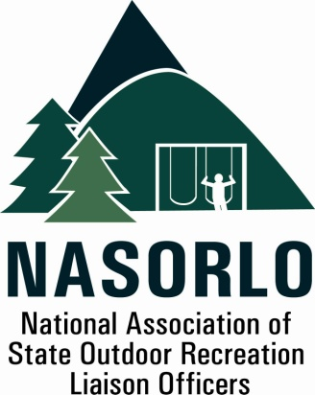

President
Linda Lanterman
Kansas

Vice President
Eric Feldbaum
New Hampshire

Secretary
Doug Beck
Maine

Past President
Lauren Imgrund
Pennsylvania

Executive Director
Doug Eiken
Missouri

Board of Directors

Randy Kittle
South Dakota

Tom Reilly
Montana

Audrey Mularie
Minnesota

Christie Bayus
Michigan

Mick Rogers
Arizona

Sedrick Mitchell
California

Dana Lagarde
Texas

John Beneke
Arkansas

Antoinette Norfleet
Georgia

Gerald Parish
Tennessee

Janice Keillor
Nevada

Robert Ehemann
Delaware

105H, ABNR BUILDING
UNIVERSITY OF MISSOURI
COLUMBIA, MO 65211-7230
573-353-2702

NASORLO 2021 LWCF Resolution G.

PREAMBLE

The National Association of State Outdoor Recreation Liaison Officers (NASORLO), are appointed officials of the State and Territorial Governors who are the chief administrators of the federal Land and Water Conservation Fund Stateside Assistance (LWCF) throughout the United States and US Territories. Actions by current and past NASORLO members have resulted in projects which have developed and protected outdoor recreation parks and recreation areas in every geographic region of the United States, every county, nearly every city or town, and throughout our territories.

WHEREAS, on September 3, 1964, President Lyndon Johnson, signed into law the Land and Water Conservation Fund Act, passed by the United States Congress, to provide urban and rural outdoor recreation opportunities on state, federal and local lands for all Americans. When the Act was passed by Congress its primary purpose was to provide outdoor recreation for Americans in close to home locations and guaranteeing that sixty percent (60%) of the Act’s funds were to be dedicated to the states and territories; and

WHEREAS, over the past 56 years the LWCF Act created the most successful federal/state/local outdoor recreation partnership in history, which generated hundreds of millions of dollars in matching funds from private, local and state sources to at least double the federal funds for outdoor recreation projects; and

WHEREAS, in excess of 42,000 grants to states and localities were awarded LWCF State Assistance Grants Program funds over the past 56 years for acquisition, development and planning of outdoor recreation opportunities in 99% of the nation's counties. These grants represent an investment of $4.2 billion in federal LWCF assistance, matched with private, local and state sources representing a minimum total of $8.4 billion for outdoor recreation. These collectively provide close-to-home recreation opportunities readily accessible to America's youth, adults, senior citizens and the physically or mentally challenged; and

WHEREAS, the LWCF Act was recently permanently re-authorized by the John D. Dingell Conservation, Management and Recreation Act of 2019 which restored a 40% share for the State Assistance Program and the Greate American Outdoors Act passed in 2020 that permanently provides a $ 900,000,000 to the LWCF on an annual basis; and

WHEREAS, a state by state assessment by the National Park Service, the federal administrator of the LWCF, and NASORLO have shown a significant unmet needs for outdoor recreation in state, local and urban areas; and

WHEREAS, NASORLO will play an active advisory role in the implementation of the Great American Outdoors Act and convene relevant stakeholders to advocate for successful rollout of increased grants to the State Assistance Program; and

WHEREAS, a recent assessment of the potential economic impact generated from the expected infrastructure projects using the State Assistance Program for FY 21 is estimated in-excess of $ 554 million dollars and supports 8918 jobs; ( 2020 IUE construction data )

WHEREAS, NASORLO looks forward to working with the National Park Service and all interested stakeholders, including the nation's Governors, Congress and the Administration towards efficient and effective management of the LWCF State Assistance Program, and

WHEREAS, NASORLO and its state and territorial members seeks authority to allow the use of a percentage of the annual allocations to administer and oversee the stewardship of the program at the state and territorial level; and

WHERAS, NASORLO seeks the maximum use of LWCF state grants during the economic recovery period following the pandemic and has recommended a temporary reduction in the state and local 50% matching requirement; and

WHEREAS, The NASORLO Board of Directors met on April 16th, 2021 for purposes of discussing the ongoing issues related to the state and territorial administration of the Land and Water Conservation Act and made important suggestions and recommendations to improve the State Assistance Program of the LWCF.

NOW THEREFORE BE IT RESOLVED, the National Association of State Outdoor Recreation Liaison Officers Board on behalf of its Membership requests that Congress direct the Department of the Interior and the National Park Service to consider the following recommendations made by the Board of Directors, that; 1. A working group be established and empowered to address the policies and rules regulating the administration of the State Assistance Program; 2. Authorize up to 10% of the annual apportionment for each state and territory to be used for administration. 3. And ensure that 40% of each years LWCF be dedicated to State outdoor recreation grants.

Dated the 16th Day of April, 2021

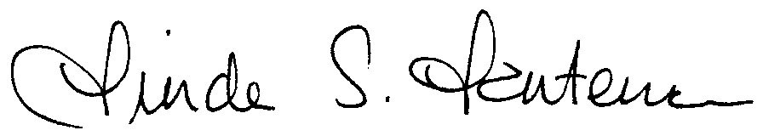

Linda Lanterman, President

