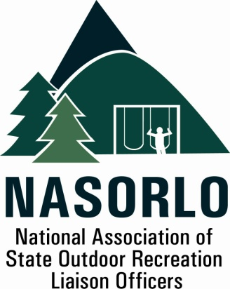

President
Linda Lanterman
Kansas

Vice President
Eric Feldbaum
New Hampshire

Secretary
Doug Beck
Maine

Past President
Lauren Imgrund
Pennsylvania

Executive Director
Doug Eiken
Missouri

Board of Directors

Randy Kittle
South Dakota

Tom Reilly
Montana

Erika Rivers
Minnesota

Christie Bayus
Michigan

Mick Rogers
Arizona

Sedrick Mitchell
California

Dana Lagarde
Texas

John Beneke
Arkansas

Antoinette Norfleet
Georgia

Gerald Parish
Tennessee

Janice Keillor
Nevada

Robert Ehemann
Delaware

105H, ABNR BUILDING
UNIVERSITY OF MISSOURI
COLUMBIA, MO 65211-7230
573-353-2702

LWCF State Grants Assisting Communities in Economy Recovery

Problem Statement: The nation is facing an unprecedented situation caused by the economic impacts of a world wide pandemic. To restart and restore economic stability and the outdoor recreation infrastructure to meet community needs requires bold action. The state and local grants portion of the LWCF can be used to facilitate this recovery.

Proposal.. NASORLO has documented how state and local grants are a unique vehicle to provide not only outdoor recreation but at the same time stimulate the local and state economy. State and local government revenues are severely impacted by the loss of revenue from the lock down of the economy. Therefore we are proposing temporary changes to the LWCF state grants program until the economy has recovered and use the LWCF State Assistance Program to support the economic recovery and provide improved outdoor recreation.

We base this proposal on the following data.

A. We found significant benefits to state and local economies because of the data from a recent NASORLO survey. It found that;

  - 85% of state and local LWCF grants are awarded for construction and infrastructure improvements. The expenditure of these funds typically benefits local and regional economies creates jobs and supports resiliant communities.

The proposal outlined below seeks to incorporate an adjustment in the appropriations language which changes the matching requirement of the LWCF for a five year period. This action seems appropriate, given that state and local project data show these projects, in addition to providing close to home recreation, also generate related economic activity and support employment.

To obtain the maximum benefits and realize the potential of this proposal would require the following changes for project grants and project administration.

- FY 21 - 25 We propose to reduce the required match for outdoor recreation projects to 20 %, This change is justified based upon the types of projects typically funded with state and local rants and will give state and local governments, who provide the matching funds, time for their revenues to recover.
- To recognize the importance of efficient state administration of these funds will also require assistance; therefore, we are recommending that up to 10 % of each state's LWCF apportionment be made available for administration, similar to that of other federal grant programs.
- And that the timeframe for obligating each grant be extended from the current three years to five years.

Economic activity and jobs supported.. Based upon our estimates, with full funding of LWCF and continued focus on restoration and development of outdoor recreation projects thoughout the nation would result in an estimated one half billion dollars annually into state and local economies. The state grants program distributes these benefits equally into both urban and rural areas, as the National Park Service data shows all counties in the nation have received LWCF grants.

